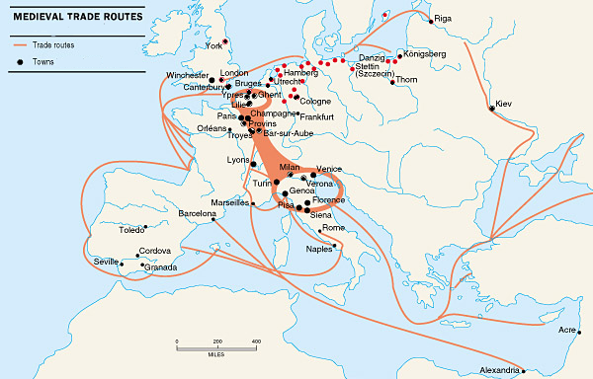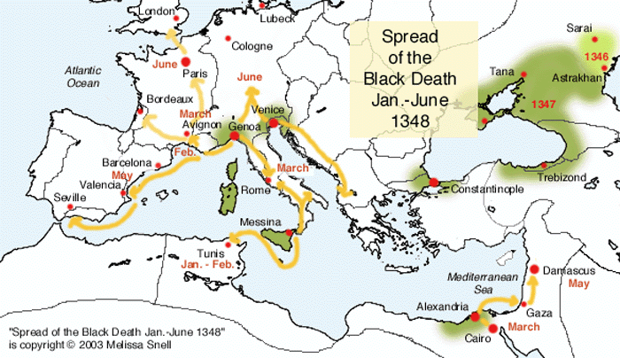

**A Map showing the Medieval Trade Routes**

**A Map showing the spread of the Black Death**

**A Map showing the Medieval Trade Routes**

**A Map showing the spread of the Black Death**

**A Map showing the Medieval Trade Routes**